**ARCHITECTURE DOCUMENT**

Architecture Diagram:

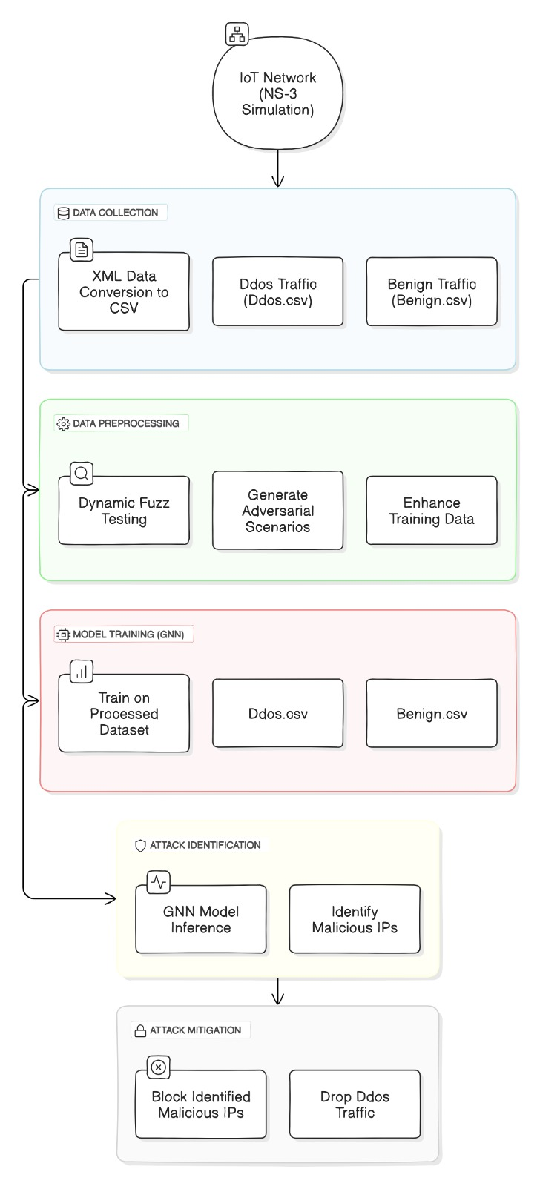

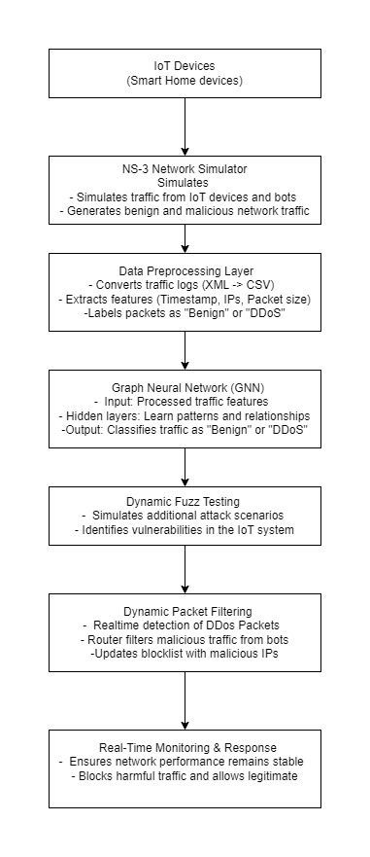Scheme Diagram:

E-R Diagram:

